**NodeMcu 8266 As a WiFi access point:**

In this point , We use NodeMcu as a Server which has its own wifi name and password.

In this code we need two things to make a NodeMcu as a wifi or Hotspot server,

* WiFi.softAP("Give a server name ", " Give password");
* Serial.println(WiFi.softAPIP());

Code:

|  |
| --- |
| #include<ESP8266WiFi.h> WiFiClient client; WiFiServer server(80); #define led D7 void setup() {   // put your setup code here, to run once:   Serial.begin(9600);   WiFi.softAP("NodeMcu","123456789");   Serial.println();   Serial.println("NodeMcu started!");   Serial.println(WiFi.softAPIP());   server.begin();    pinMode(led,OUTPUT); }  void loop() {   // put your main code here, to run repeatedly:   client = server.available();   if (client == 1)   {     String request = client.readStringUntil('\n');     Serial.println(request);     request.trim();      if (request == "GET /ledon HTTP/1.1")     {       digitalWrite(led,HIGH);     }      if (request == "GET /ledoff HTTP/1.1")     {       digitalWrite(led,LOW);     }   } } |

After uploading this code into NodeMcu8266 we will see a wifi network named NodeMcu in our phone or any device’s wifi Netwok

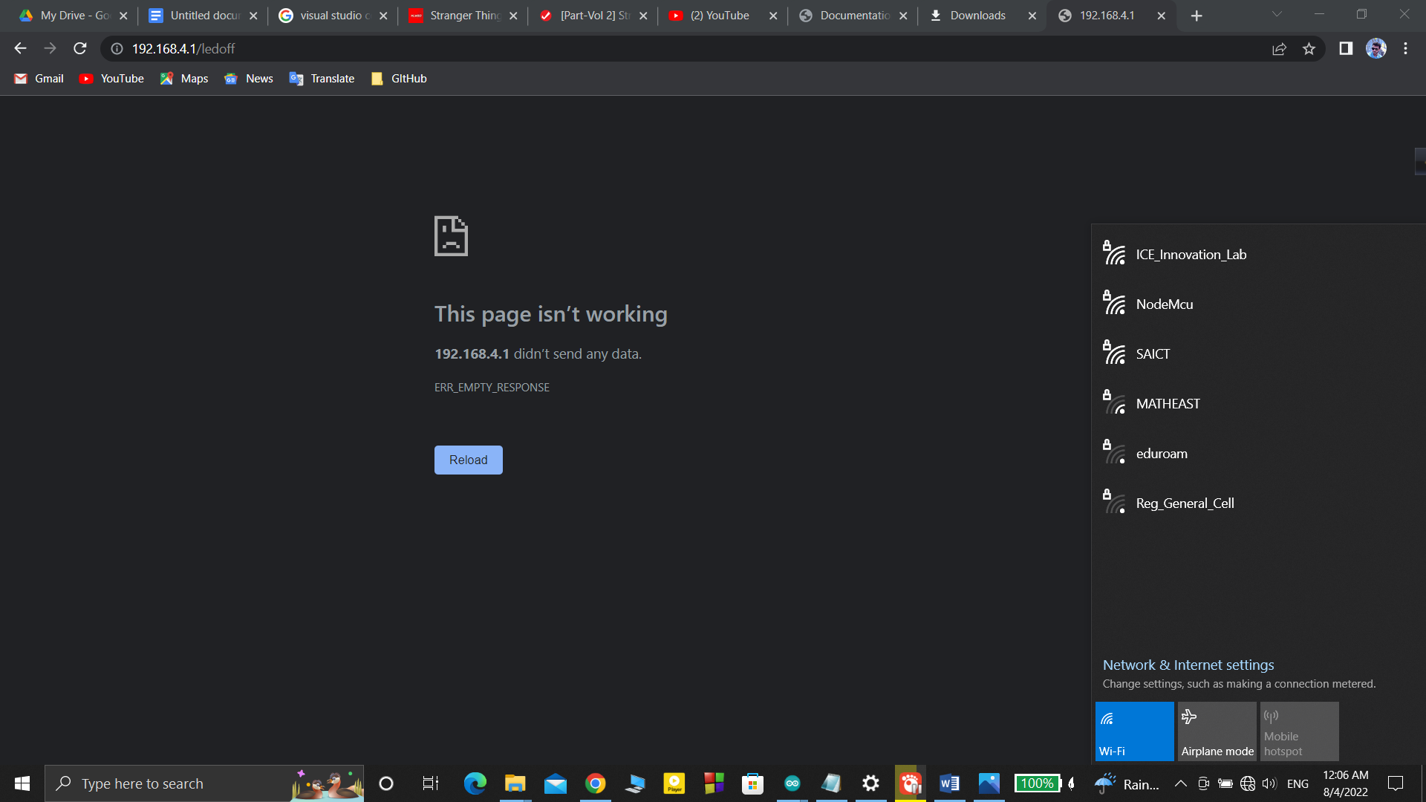

After connecting this network we will control Led light with its ip